**SUN, SHYI-REN**

Date of Birth: 23 August 1961

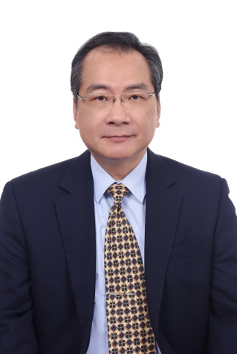

**ACADEMIC BACKGROUND**

B.A., Department of Political Science, National Taiwan University

**CAREER**

* **16/01/2019－**

Representative, Taipei Trade Office in the Kingdom of Bahrain

* **26/02/2018－11/01/2019**

Chief of Staff to the Secretary-General, National Security Council, Republic of China (Taiwan)

* Chief of Staff to the Foreign Minister, Ministry of Foreign Affairs, Republic of China (Taiwan)
* Minister on Home Assignment, Institute of Diplomacy and International Affairs, Ministry of Foreign Affairs, Republic of China (Taiwan)
* Minister, Embassy of the Republic of China (Taiwan) to St. Lucia
* Counselor, Embassy of the Republic of China (Taiwan) to St. Lucia
* Deputy Consul-General, Taipei Economic and Cultural Office in New York
* Deputy Secretary-General, Coordination Council for North American Affairs, Republic of China (Taiwan)
* First Secretary on Home Assignment, Secretariat, Ministry of Foreign Affairs, Republic of China (Taiwan)
* First Secretary, Taipei Economic and Cultural Office in Malaysia
* Private Assistant to the Foreign Minister, Ministry of Foreign Affairs, Republic of China (Taiwan)
* Section Chief, Department of North American Affairs, Ministry of Foreign Affairs, Republic of China (Taiwan)
* Section Chief, Coordination Council for North American Affairs, Republic of China (Taiwan)